GIS Methods for Economists:

Google Drive Setup

Abstract

This guide explains how to connect your own personal Google drive to the Google drive shared folder containing all the course materials. If you get stuck on any step, please re-read it carefully and make sure you follow it exactly. If you are still stuck, please contact wibdresearch@london.edu with a description of your problem, including screenshots.

1. Open a browser and go to https://www.google.com/intl/en/drive/. Sign in to your google account. If you don’t have a google account, create one and then sign in.

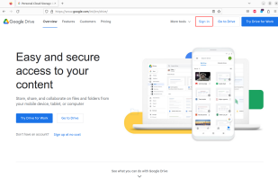1

2. Go to https://drive.google.com/drive/folders/1KLGvwvw5pSQbir OqyCukBzEyN3g2xcjI?usp=sharing

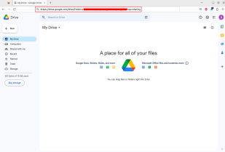

3. Click on “Shared with me” on the left. You should see a folder called GIS Research 2023.

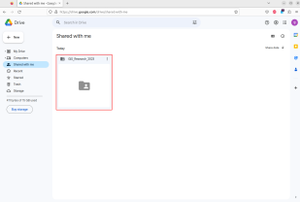2

4. Right click on this folder *→* “Add shortcut to Drive“ *→* Select “My Drive” and click “ADD SHORTCUT”.

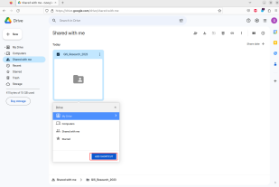

5. Go back to “My Drive” on the left. You should see a folder GIS Research 2023 appear as one of your folders. Open it.

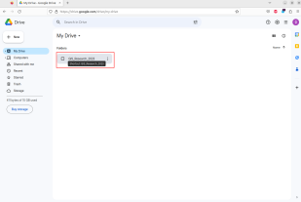3

6. Open the folder for lecture 2

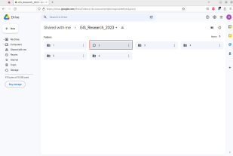7. Open the code folder.

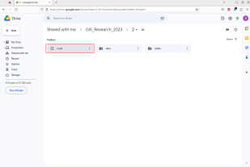4

8. Open the notebook 05 projections.ipynb

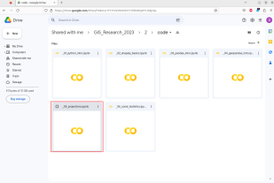9. In the first code cell, remove the “# ” from “# %pip install geopandas”. 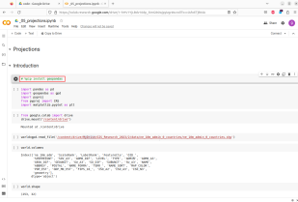

5

10. While in the first cell, press SHIFT-ENTER.

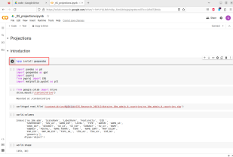

11. Authorize the running of the notebook by clicking on “Run anyway”. This will install the geopandas package for this Google colab session.

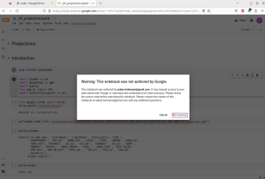6

12. Press SHIFT-ENTER again in the second code cell and in the third code cell. In the next pop-up, click on “Connect to Google Drive”.

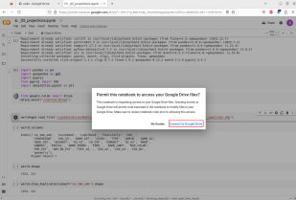13. Choose the Google account you are currently logged in as. 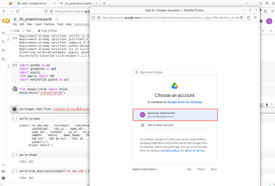7

14. Click “Allow”

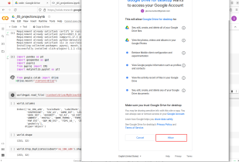

15. Press SHIFT-ENTER in the next two code cells. You should see the following output

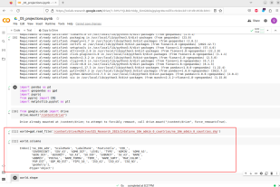This concludes the setup required for the course. See you in class!

8